Interim Report for Project Entitled:

Feasibility Study for In-Home Storm Shelters in Florida Residential Homes
PO Number A95F33

Performance Period: 1/6/2014 – 6/30/2014

Submitted on

March 14, 2014

Presented to the

Florida Building Commission
State of Florida Department of Business and Professional Regulation

by

Forrest J. Masters, Ph.D., P.E., masters@ce.ufl.edu, (352) 392-9537 x 1505, Principal Investigator
Kurtis R. Gurley, Ph.D., kgurl@ce.ufl.edu, (352) 392-9537 x 1508
David O. Prevatt, Ph.D., P.E. (MA), dprev@ce.ufl.edu, (352) 392-9537 x 1498
Austin Thompson, a.thomp@ufl.edu
Keith Clabaugh, krclabau@ufl.edu

Designated Project Leader: David O. Prevatt

Engineering School for Sustainable Infrastructure & Environment

Table of Contents

Table of Contents
1. Executive Summary 1
1.1. Description of Issues 1
2. Scope of Work 1
3. Deliverables 1
4. Progress of Work to Date 2
4.1. Review of Design Guidelines 2
4.2. Review of Previous Research on Structural Performance of In-Home Shelters 2
4.3. Review of Previous Research on Windstorm Risks (Hurricanes and Tornadoes) in Florida 3
4.4. Shelter-in-Place Options 4
4.5. Recommended Shelter-in-Place Design Option 5
5. References 6
6. Appendices 7
6.1. Appendix A – Austin Thompson’s Time Sheet 7

Executive Summary

The primary focus of this project is to investigate the feasibility of in-home storm shelters in Florida residential structures and recommend retrofit options to provide cost effective protection from hazards associated with tornados, hurricanes, or a severe windstorm.

The State of Florida has seen substantial improvements in the wind resistance of residential buildings and in building code provisions, particularly since Hurricane Andrew. The evidence of this improvement came with the passage of the four hurricanes in 2004. Gurley and Masters (2010) found a statistically significant improvement in the performance of new homes, (i.e. homes built after 1994), following the 2004 hurricane season. Still, there remains concerns as to the structural capacity of the existing residential construction, in particular those structures built before 1994 when new wind resistant design guidelines were introduced.

Florida’s population is 19 million residents, and there are approximately 9 million single-family homes. 70% of these structures (or 6.3 million homes) were constructed in or before the 1994 changes to the building code. Therefore, assuming the majority of these existing homes have not already been upgraded, one can expect over 6 million Florida homes are liable to have inadequate connections and structural systems. This is the group of buildings that is the focus of this study.

Description of Issues

The Florida Building Commission Staff raised the issues about designing or construction of in-home shelters. What are existing requirements (if any), and are they appropriate for use in single-family Florida homes? Should in-home shelters be designed to resist tornado as well as hurricane strength loads? What testing is required to evaluate the tornado and/or hurricane resistance of an in-home shelter? What are the costs and benefits of implementing a program to install in-home shelters in Florida homes?

This interim report presents the University of Florida’s work to address the following task to:

Develop guidelines for strengthening a room or an area within an existing home necessary to achieve an acceptable level of protection from a severe windstorm”.

Scope of Work

The original scope of work is listed below.

- Review available design guides, reports and recommended practice on storm shelters, and methods for retrofitting of existing houses.
- Summarize shelter-in-place options, retrofit solutions and present their advantages and disadvantages.
- Synthesize knowledge and develop selection criteria for suitability of a house to have shelter-in-place hardened areas within existing light-framed wood and masonry residential structures.
- Summarize and present recent knowledge on geographical variations of severe windstorm risks (hurricanes and tornadoes) in Florida, and develop an in-home shelter load model.
- Recommend in-home shelter design options, including schematic renderings for an existing residential structure considering the cost, size and practicality of design and impact of Florida’s mixed (hurricane and tornado) climatology.
- Develop outline scope of work for Phase II – Detailed Engineering and Testing of Structural Components for a Hardened Shelter-in-place Room in an Existing House.

Deliverables

- An interim report will be submitted to the Program Manager by March 15, 2014
- A breakdown of the number of hours or partial hours, in increments of fifteen (15) minutes, of work performed and a brief description of the work performed. The Contractor agrees to provide any additional documentation requested by the Department to satisfy audit requirements.

Summary of Work to Date

Review of Shelter Design Guidelines

- FEMA 320 (2008)
  - Prescriptive Design standards for In-Home Safe Rooms
  - FEMA safe rooms that provide near-absolute life safety protection during tornado and hurricane events
  - Design wind velocity of 250 mph
  - Resist missile impact of 15 lb 2x4 in. at 100 mph
- FEMA 361 (2008)
  - Prescriptive Design standards for Community Safe Rooms
  - Interior shelters only - i.e. no exterior walls, separate floor slabs, independent roof structure
  - Allowable floor space – 3 ft² per person for tornadoes, and 7 ft² per person for hurricanes
- ICC-500 (2008)
  - Prescriptive and codified the design guidelines from FEMA 320 and FEMA 361 to create minimum standards for storm shelters.
- National Performance Criteria for Tornado Shelters (1999)
  - Engineering Design standards for In-Home Safe Rooms
  - FEMA criteria for shelters to withstand the effects of high winds and debris generated by tornadoes such that all occupants will be protected without injury during a tornado.
- Georgia State International Residential Code Appendix R : Disaster Resilient Construction (2013)
  - Designed to improve existing provisions in the codes relating to hurricane, flood, and tornado disasters
  - Provides enhanced minimum requirements for development of new construction and substantial improvement of existing development above that contained in the IRC
  - The only requirement for residential storm shelters and safe rooms is that residential storm shelters comply with ICC-500

Review of Previous Research on Structural Performance of In-Home Shelters

- Carter (1998) – Wind-Generated Missile Impact on Composite Wall Systems (Texas Tech)
  - Tested composite wall systems to be used for occupant protection against wind generated missiles
  - Tested 30 wood and 3 masonry composite wall systems
  - Air canon accelerated 15 lb 2x4 in. missile over 100 mph
  - 4 layers of ¾” plywood provides almost near-absolute protection (up to 60 lb-s)
  - Determined the response of impacted wall systems can be classified using concepts of impact dynamics
  - Stated that more work needed to be done
- Reinhold et al. (2000) – Enhanced In-Home Protection from Severe Winds (Clemson)
  - Tested 36 wood-frame wall sections for minimum penetration force
  - Tests conducted using 9 lb 2x4 missile and wall sections made of common construction materials
  - Impact momentum measured in lb-s to relate data to TTU testing
  - Documentation of first damage and through penetration for each wall section
  - Developed a linear momentum model related to ultimate strength of a FEMA/ICC Storm Shelter (68 lb-s)
  - Proposed wall sections for 20%, 40%, and 60% of ultimate capacity
- Reinhold et al. (2002) – Case for Enhanced In-Home Protection from Severe Winds (J. Archit. Eng.)
  - Summarized Clemson report on impact wall testing
  - Proposed pros and cons for strengthening a home versus installing a storm shelter as seen in Table 1.
Table 1: Pros and Cons of Strengthening a Home vs. Installing a Storm Shelter (Reinhold et al. 2002)
 | Strengthen the Whole House | Install a Storm Shelter
Pros | - House will remain habitable after windstorm  - Easier to secure windstorm insurance  - Lower premiums and smaller deductibles.  - Cost increase less than 3– 6% higher in new homes | - Can provide enhanced safety and protection during an extreme wind event.  - Various levels of protection available to the owner depending on budget  - Material cost between $500 and $1,500 (2000 $)
Cons | - Inspection requires removal of wall sheathing or sheet rock  - If serious deficiencies, expensive and difficult to resolve  - Retrofit costs to exterior envelope between $5,000 and $12,000 (2000 $). | - Not for use in flood-prone areas.  - Cannot provide security for valuables not already stored in the shelter.  - House may still be completely damaged.  - Does not provide near-absolute protection

- Yazdani et al. (2006) – Construction Aspects of In-Home Hurricane Wind Shelter Rooms (J. Coastal Research)
  - Hurricane-proof in-home shelter for existing homes
  - Step down from FEMA tornado safe room
  - Shelter Designed for winds up to 180 mph
  - Average cost of $3100

Review of Previous Research on Windstorm Risks (Hurricanes and Tornadoes) in Florida

- Vickery et al. (2009) – Ultimate Wind Load Design Gust Wind Speeds in the United States for Use in ASCE-7 (J. Struct. Eng.)
  - ASCE 7-10 approach employed in the development of the design wind speed maps for US
  - Three wind speed maps provided with Mean Recurrence Intervals of 300,700, and 1700 years for three building categories
  - Design wind speed for houses (Risk Category II) in Florida is 120 mph through 180 mph as seen in Figure 2
- Marshall and McDonald (2004) – The Enhanced Fujita Scale (AMS Conference)
  - The Fujita Scale was first proposed in 1971 and has was used to rate the intensity of tornadoes using the degree of damages that tornadoes create and then classified them into six categories as seen in Table 2.
  - Although the Fujita Scale had been in use for thirty years, there are limitations such as a lack of damage indicators, insufficient consideration of construction quality and variability, and no definitive correlation between damage and wind speed.
  - The Enhanced Fujita Scale that was adopted in 2007 and is in use today.
  - The EF scale estimates the failure wind speeds that cause damage to certain damage indicators which are structures or objects that can sustain specific levels of damage which can be related back to wind speeds.
  - There are 28 damage indicators as seen in Figure 1 that each have a Degree of Damage scale with 10 specific damage descriptions that relates to a wind speed range. Once the specific wind speed is estimated the EF rating is assigned as seen in Table 2

Table 2: Comparison of Fujita and Enhanced Fujita Scales
Intensity | Wind Speeds (3-second Gust, mph)
 | F-Scale | EF-Scale
0 | 45 – 78 | 65 – 85
1 | 79 – 117 | 86 – 109
2 | 118 – 161 | 110 – 137
3 | 162 – 209 | 138 – 167
4 | 210 – 261 | 168 – 199
5 | 262 - 317 | 200 - 234

Figure 1: Progression EF Scale Determination

- Twisdale and Dunn (1983) – Probabilistic Analysis of Tornado Wind Risks (J. Struct. Eng.)
  - Developed a method to estimate risk for tornadoes by using the observed characteristics of tornadoes, such as width, length, and intensity to generate a probabilistic tornado wind field model.
  - Using the tornado wind field model with a Monte Carlo simulation to generate probabilities of exceedance for tornadoes for a given point or area.
- Roueche and Prevatt (2013) – Evaluating Mitigation Effectiveness (University of Florida)
  - Used Twisdale and Dunn (1983) method to develop probabilities of exceedance for the state of Florida
  - In Florida, 60% of the reported tornadoes are EF0 as opposed to 45% nationally. Only about 1% of the tornadoes in Florida are EF3≤ with two EF4 and no reported EF5 tornadoes as opposed to 5% of tornadoes nationally are EF3≤ (Roueche and Prevatt 2013).
  - Used kernel density estimators to assess the spatial distribution of tornado occurrences in Florida as seen in Figure 2
  - Reasonable tornado design speed for Florida is 180 mph (+/-) compared to 250 mph in current tornado shelter design codes
- Tornado Probability of Exceedance Simulation Work to be completed
  - Divide Florida into regions based on tornado occurrence distributions
  - Develop Tornado intensity distribution model for each specified region
  - Determine the probabilities of wind speed exceedance for each region due to tornado
  - Compare ultimate wind speed for 700 year MRI of tornadoes and hurricanes
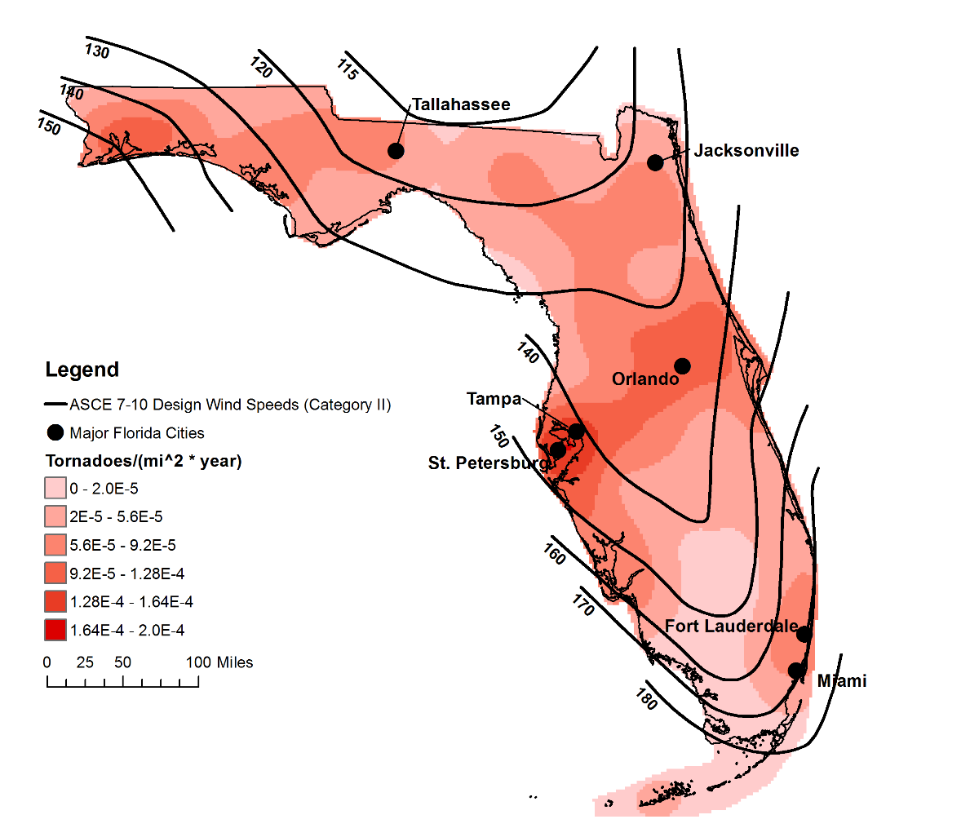
Figure 2: Kernel density estimate for Florida Tornadoes > F2 (Roueche and Prevatt 2013)

Shelter-in-Place Options

- Option 1: Shelter only – near-absolute protection, 250 mph winds and 100 mph tornado missile
  - Shelter remains even if house is completely demolished
  - Lives will be protected if directly hit by tornado
  - Expensive to construct or purchase
- Option 2: Strengthen the house: to design level winds without a storm shelter
  - House should resist design level winds
  - Difficult to retrofit
  - Requires strengthening of numerous components
  - Can be expensive
- Option 3: Strengthen home to near-absolute protection.
  - Consider the house to be a shelter
  - House will survive after a direct impact from tornado
  - Can provide shelter to the neighbors
  - Very expensive to produce
  - Likely different configuration from normal house
- Option 4: Retrofit the vulnerable connections within the home and build a hardened interior room.
  - Retrofit connections within the home and build a hardened interior room
  - Increases ductility at all joints (no brittle failure)
  - Reduces damage to house AND protects people
  - Reduces need to evacuate.

Recommended Shelter-in-Place Design Option

- Retrofit the vulnerable connections within the home and build a hardened interior room.
  - Current retrofits in hurricane resistant construction
    - Roof to wall connection
    - Wall to foundation connection
  - Suggested new retrofits
    - Wall retrofits on shelter
    - Roof retrofits on shelter
    - Enhance interior partitions to buttress exterior wall
    - Connect gable end wall to side wall (corner retrofits)
- Tornado and. Hurricane shelters have different needs and requirements as seen in Table 3
- Recommended location of shelter
  - An interior room on the first floor of the home
  - Closets, bathrooms, and small storage rooms offer the advantage of having a function other than providing occasional storm protection
  - Typically, these rooms have only one door and no windows, which makes them well-suited for conversion to a safe room. Bathrooms have the added advantage of including a water supply and toilet

Table 3: Comparison of needs for a tornado shelter vs. hurricane shelter
Tornado Shelter | Hurricane Shelter
- 2 hours  - 5 ft²/person  - Can be natural ventilation | - 24 hours  - 7-20 ft²/person  - Need food  - Need lights  - Need bathroom facilities  - Mechanical ventilation

- Case study of in-home shelter in Florida ranch style home as seen in Figure 3
  - Cost estimates of different shelter locations in Table 4
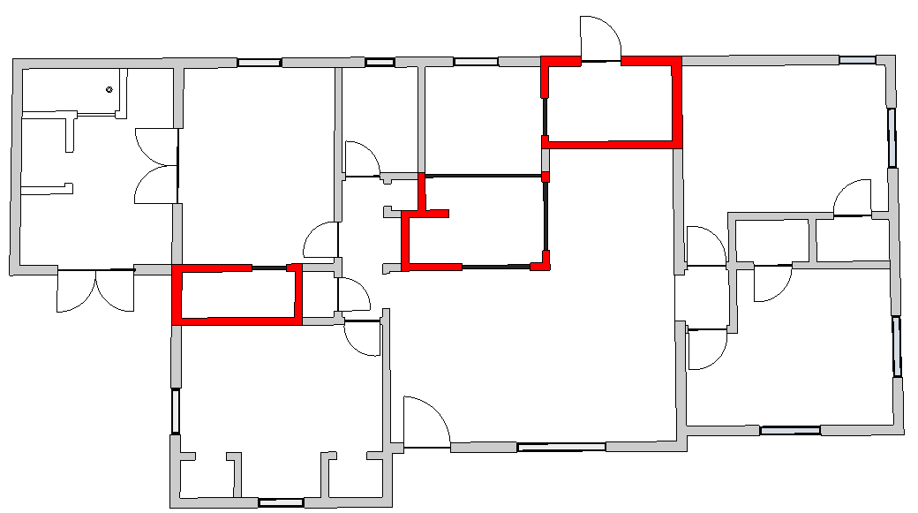
3
2
1
Figure 3: In-Home Shelter Case Study Floor Plan

Table 4: Material and Labor Costs for Shelter Options (Source: Contractor, Melbourne 2014)
Room | Size | Cost | Ease
Closet (1) | 21 ft² | $870 | - Easy to retrofit  - One Door  - Can store emergency kit  - Minimal exterior exposure
Kitchen (2) | 104 ft² | $2230 | - Near food and water  - Central location away from exterior walls  - Requires roll-down shutters or other  - Hard to enclose
Laundry (3) | 40 ft² | $1220 | - Appliance ductwork may interfere  - Multiple doors

References

Carter, R. R. (1998). "Wind-generatd missile impact on composite wall systems." Texas Tech University.
FEMA (1999). "National Performance Criteria for Tornado Shelters." Federal Emergency Management Agency.
FEMA (2008). "FEMA P-320 Taking Shelter From the Storm:Building a Safe Room For Your Home or Small Business." Federal Emergency Management Agency.
FEMA (2008). "FEMA P-361 Design and Construction Guidance for Community Safe Rooms." Federal Emergency Management Agency.
Gurley, K. R., and Masters, F. J. (2010). "Post-2004 hurricane field survey of residential building performance." Natural Hazards Review, 12(4), 177-183.
ICC (2008). "ICC-500 Standard for the Design and Construction of Storm Shelters." International Code Council.
Marshall, T. P., and McDonald, J. R. "The enhanced Fujita (EF) scale." Proc., 22nd Conference on Severe Local Storms.
Reinhold, T. A., Schiff, S. D., Rosowsky, D. V., and Sill, B. L. (2000). "Enhanced protection from severe wind storms." Dept. of Civil Engineering Rep. to the Federal Emergency Management Agency, Region IV Mitigation Division.
Reinhold, T. A., Schiff, S. D., Rosowsky, D. V., and Sill, B. L. (2002). "Case for enhanced in-home protection from severe winds." Journal of architectural engineering, 8(2), 60-68.
Roueche, D., and Prevatt, D. (2013). "Evaluating Mitigation Effectiveness: Measurement of Hurricane Wind Loads and Structural Capacities on Residential Housing." University of Florida, Florida Division of Emergency Management.
Twisdale, L. A., and Dunn, W. L. (1983). "Probabilistic analysis of tornado wind risks." Journal of Structural Engineering, 109(2), 468-488.
Vickery, P. J., Wadhera, D., Galsworthy, J., Peterka, J. A., Irwin, P. A., and Griffis, L. A. (2009). "Ultimate wind load design gust wind speeds in the United States for use in ASCE-7." Journal of structural engineering, 136(5), 613-625.
Yazdani, N., Townsend, T., and Kilcollins, D. (2006). "Construction aspects of in-home hurricane wind shelter rooms." Journal of coastal research, 862-871.

